THE UNIVERSITY OF AZAD JAMMU & KASHMIR, MUZAFFARABAD


COURSE TITLE | DSA
COURSE CODE | CS-2101
LAB TITLE | STACK AND QUEUE
STUDENT NAME | HASEEB SHEIKH
STUDENT ROLL NUMBER | 2024-SE-31
INSTRUCTOR NAME | ENGR. ASMA JAVED
SUBMISSION DATE | JAN 08, 2025

DEPARTMENT OF SOFTWARE ENGINEERING
DSA
Lab 7
Stack:
A Stack is a linear data structure that strictly adheres to the LIFO (Last In, First Out) principle. This means that the most recently added element is the first one to be removed. All insertion and deletion operations are restricted to a single end of the structure, formally designated as the top.
Core Operations
- Push: The operation of inserting a new element onto the top of the stack.
- Pop: The operation of removing the element currently at the top of the stack.
- Peek: A query operation to view the top element without removing it from the structure.

Array Implementation:
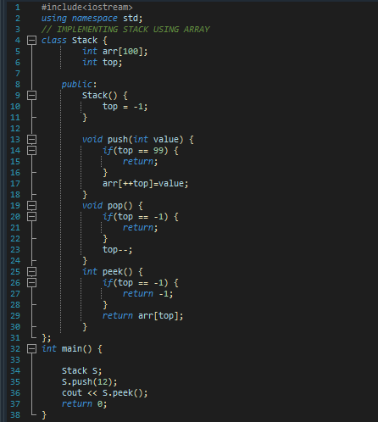

Linked List Implementation:
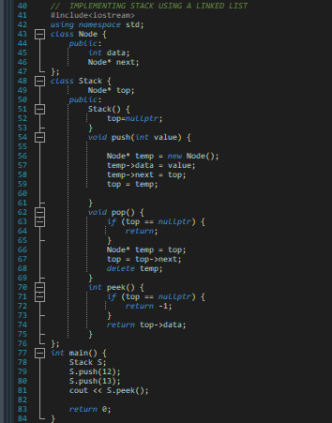

Queue:
A Queue is a linear data structure that follows the FIFO (First In, First Out) principle. In this structure, elements are inserted at one end, known as the rear, and removed from the opposite end, known as the front. This ensures that elements are processed in the exact order they were received.
Core Operations
- Enqueue: The operation of inserting a new element at the rear of the queue.
- Dequeue: The operation of removing the element currently at the front of the queue.
- Peek: A query operation to view the front element without removing it.

Structural Variations
- Linear Queue (Array).
- Circular Queue.
- Linked List Queue.
Linear Queue:
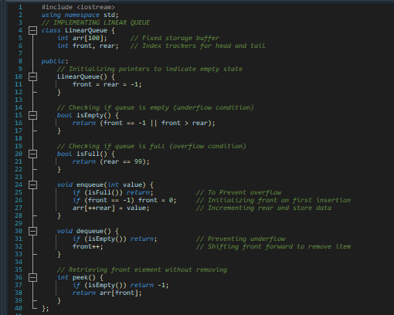

Main
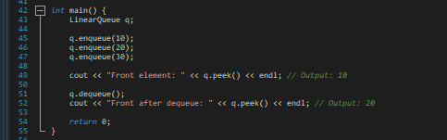

Explanation
- Pointers: Uses front to track the first item and rear to track the last item. Both start at -1.
- Movement: enqueue increments rear (++rear) to add data, while dequeue increments front (front++) to remove it.
- Limitation: It checks if rear == 99 to see if it is full, meaning empty space at the beginning cannot be reused.
- First Element Initialization: When enqueue is called on an empty queue (front == -1), the front index must be manually set to 0 to mark the start of the line.
- Hard Limit: The size is static (e.g., arr[100]), meaning the program will fail or reject data if you exceed this limit, regardless of available system RAM.
Circular Queue:

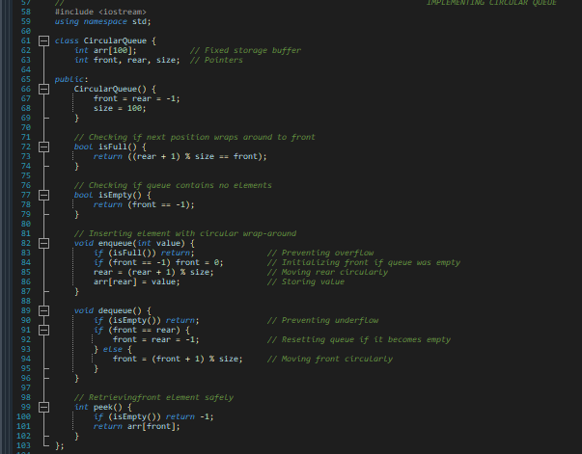

Main
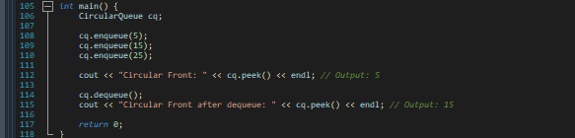

Explanation

- Modulus (%): Uses (rear + 1) % size to move the pointer back to index 0 when it reaches the end of the array.
- Full Condition: It is full only when the next position of rear lands exactly on front ((rear + 1) % size == front).
- Efficiency: This logic connects the end of the array to the start, allowing the reuse of empty slots.
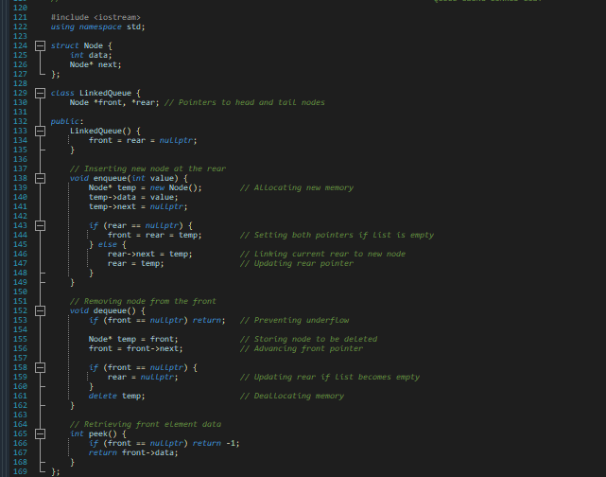
Queue Using Linked List:

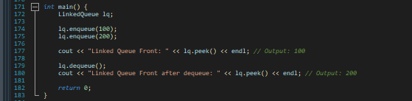
Main

Explanation
- Two Pointers: front is used to delete nodes (Head), and rear is used to add new nodes (Tail) .
- Linking: When adding, we link the current rear->next to the new node, then update the rear pointer to sit on that new node.

